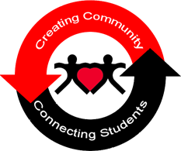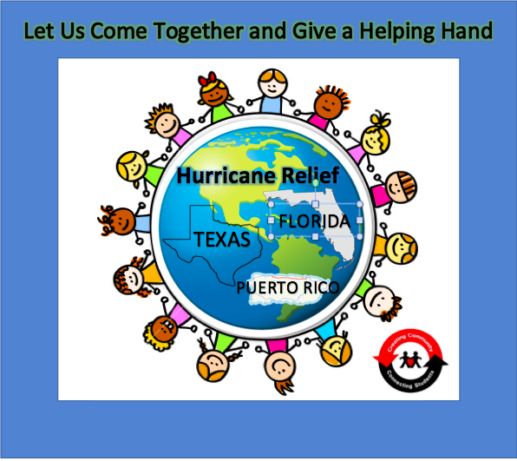

**JOIN our YAMMER group (through Office 365 on blackboard) for more information!**

For more information, please contact the CSRC located in 101 Alumni Hall (607) 436-2098

Everyone has the ability to make a difference but together we can achieve more. When we combine efforts, we have the capability to make small projects into large successful ones.

Help us Help Others

Hurricane Relief

College Wide Fundraising Effort